Our guests from America:  
  
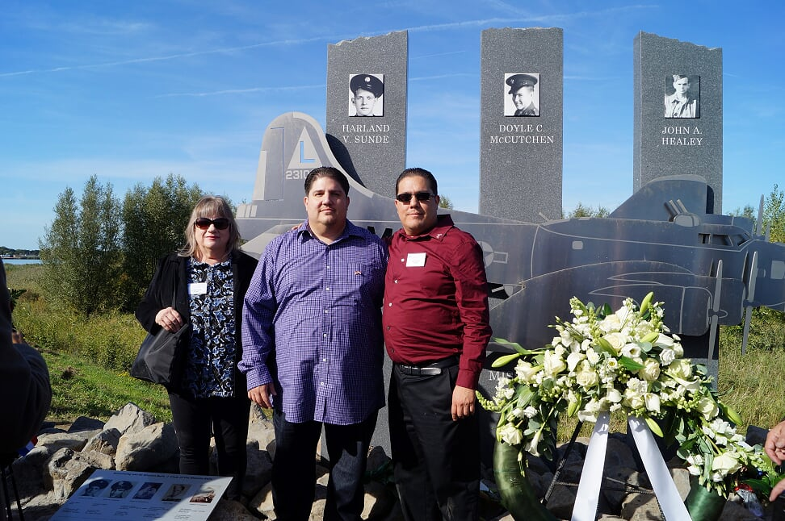  
Ero Aguirre, Roman Aguirre and Gabriel Aguirre  
  
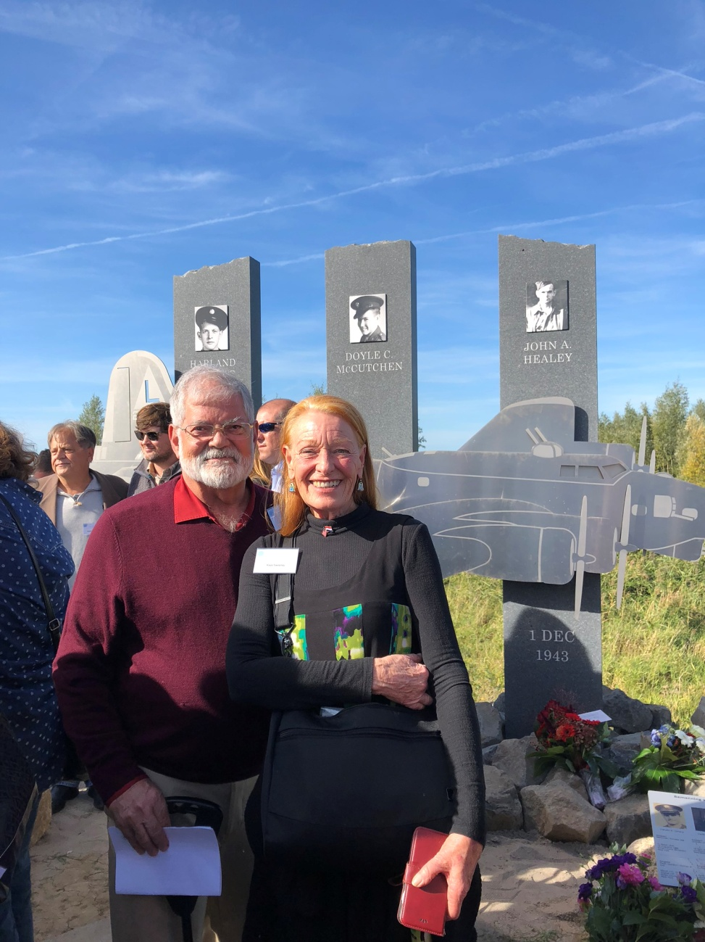  
Jim Sweaney and Kaye Sweaney

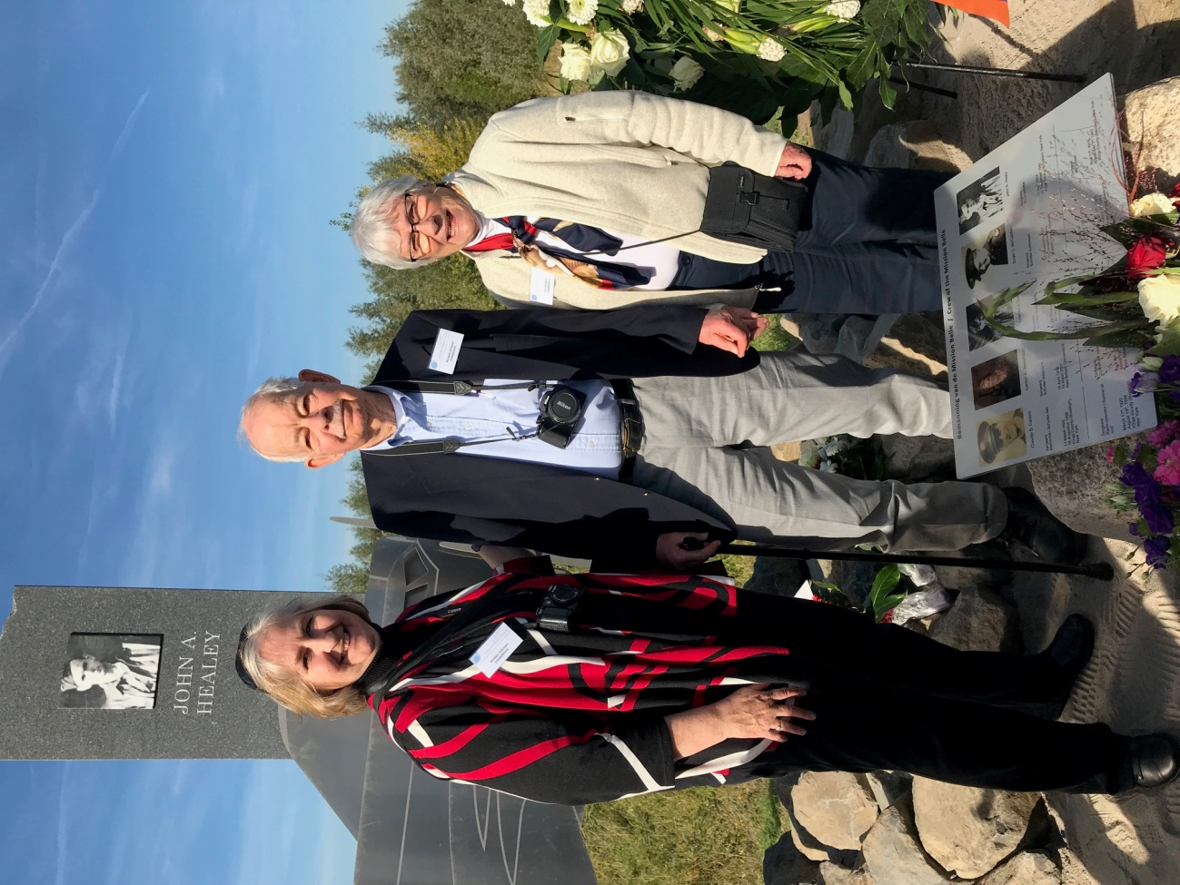

Kristen Johnson, Richard Johnson and Elizabeth Johnson

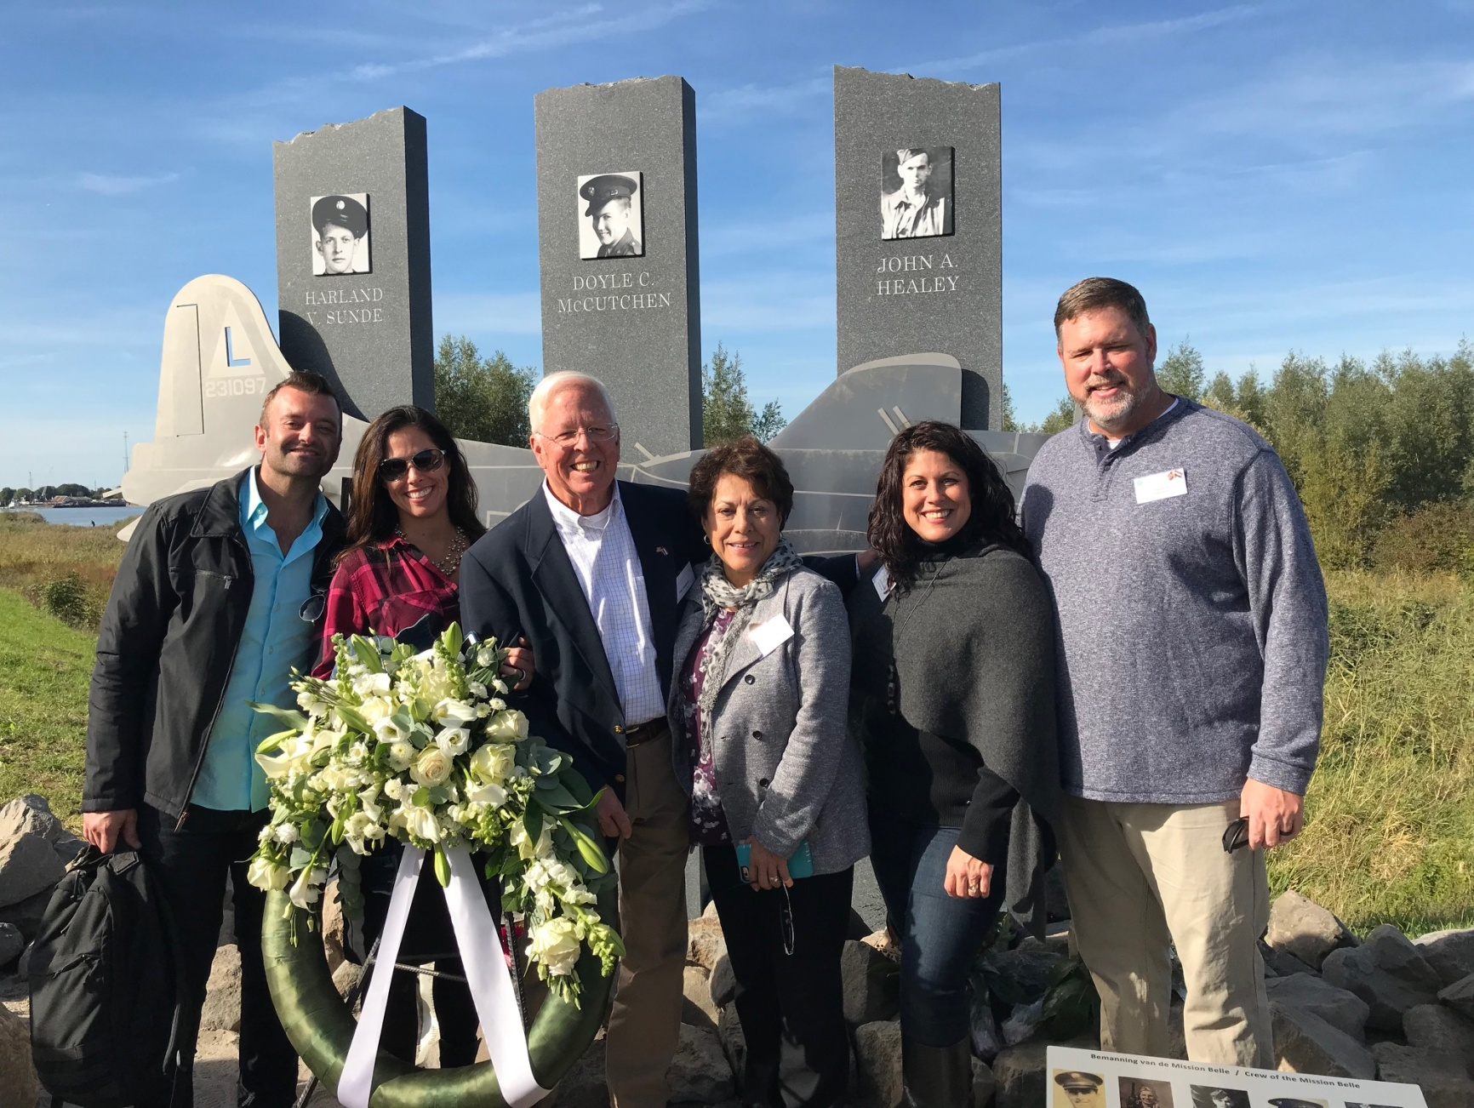

Brian Runnels, Christine Runnels Josephson, Paul Josephson, Cynthia Josephson, Jennifer Brush Josephson and Brad Brush

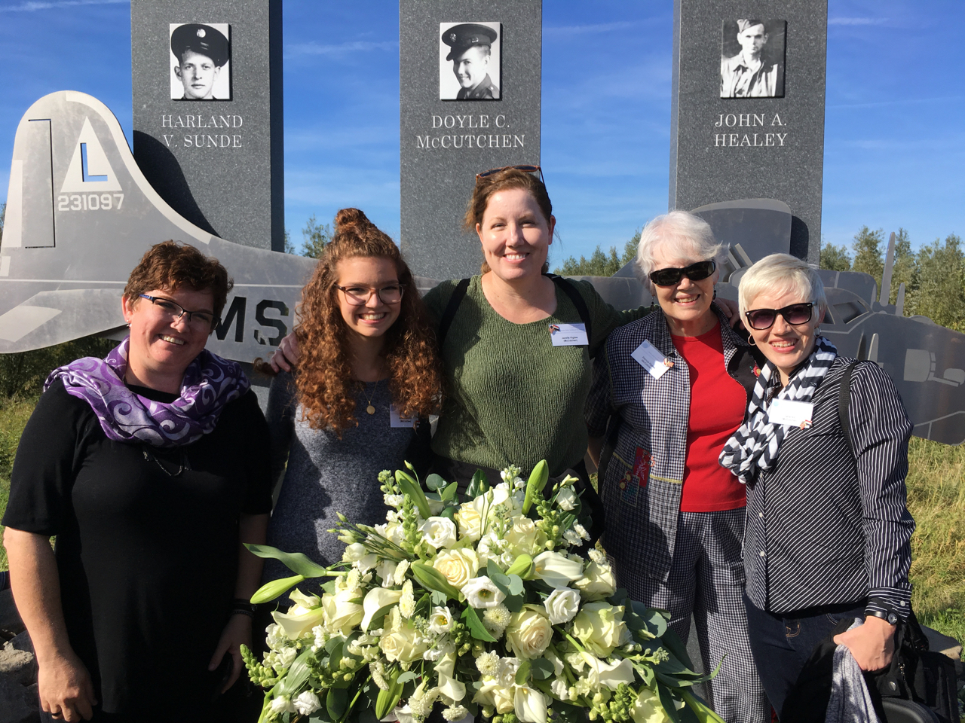

Dawn Roberts, Adelia Roberts, Janelle Higbee, Patricia Higbee and Lana Hill

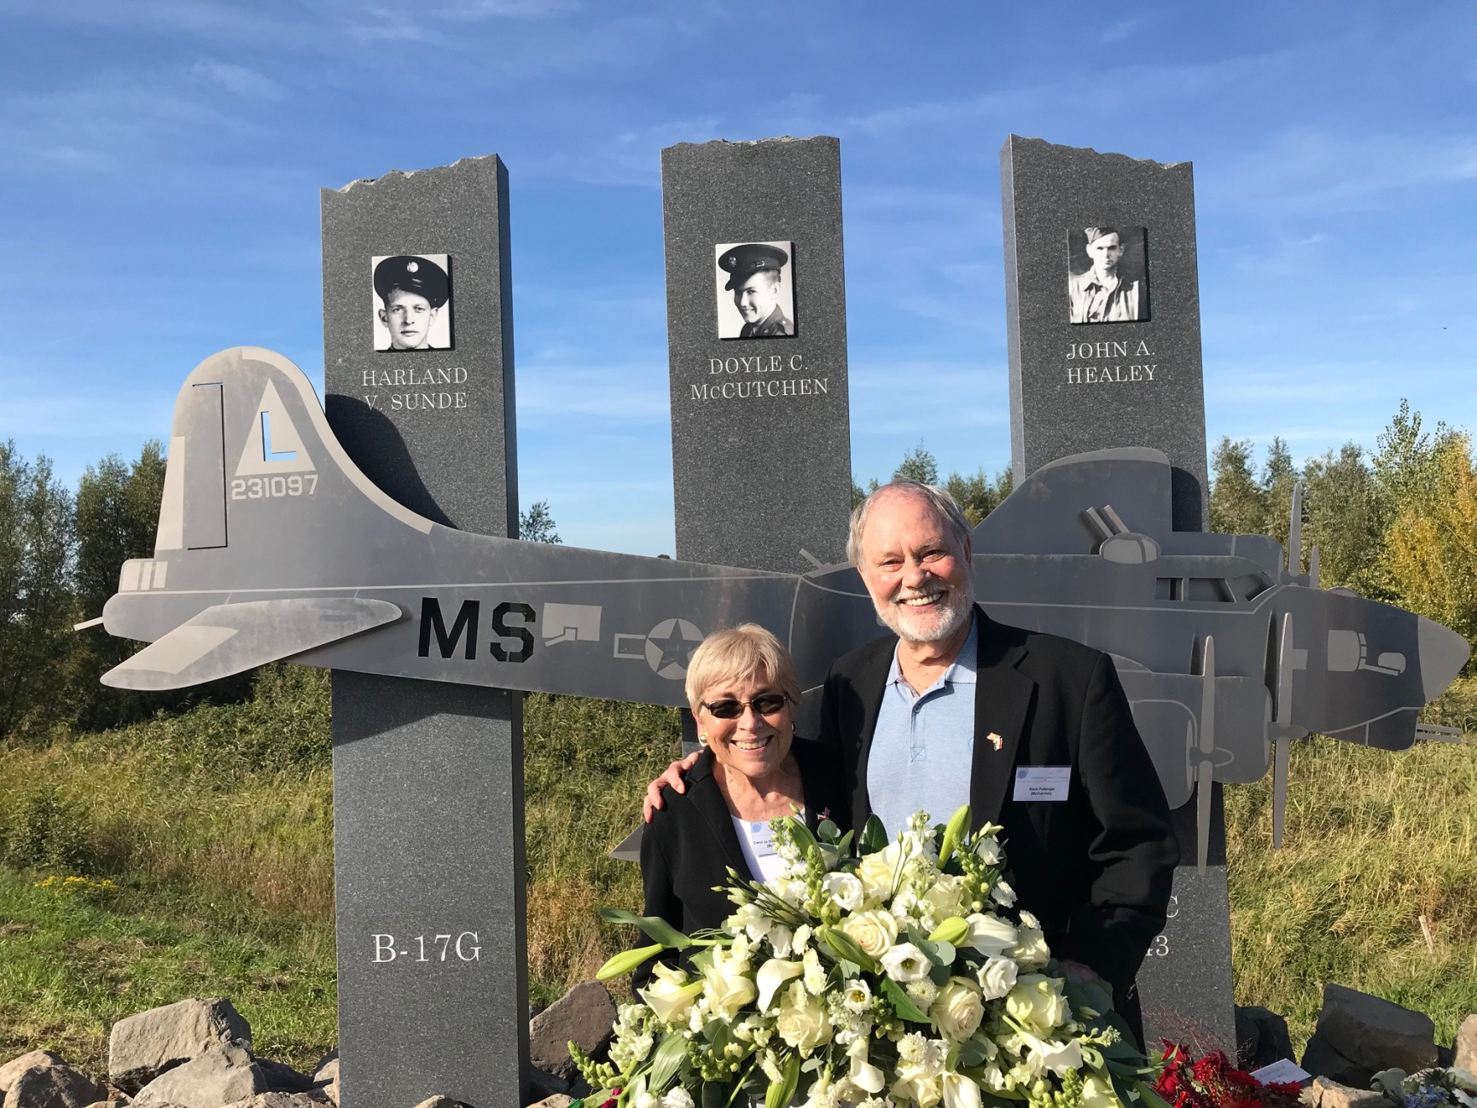

Carol Jo Pottenger and Ken Pottenger

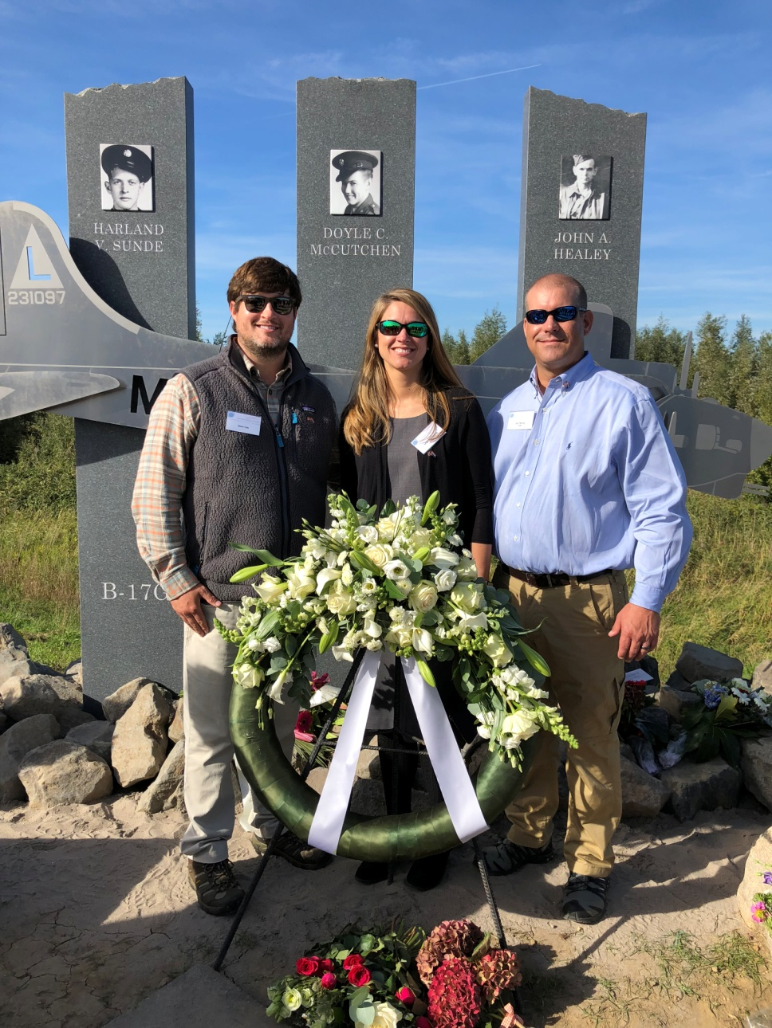

Blake Tully, Leigh Ann Fleming (Tully) and Zac Fleming

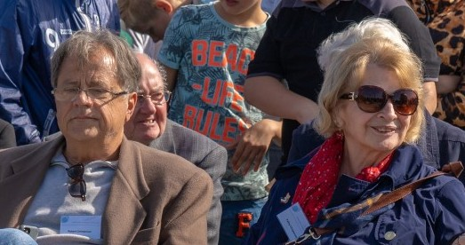

Bob Christensen and Kathy Christensen

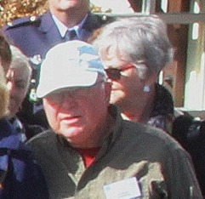

Bob Berger and Charlene Berger

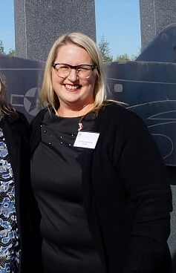

Jana Churchwell Scott

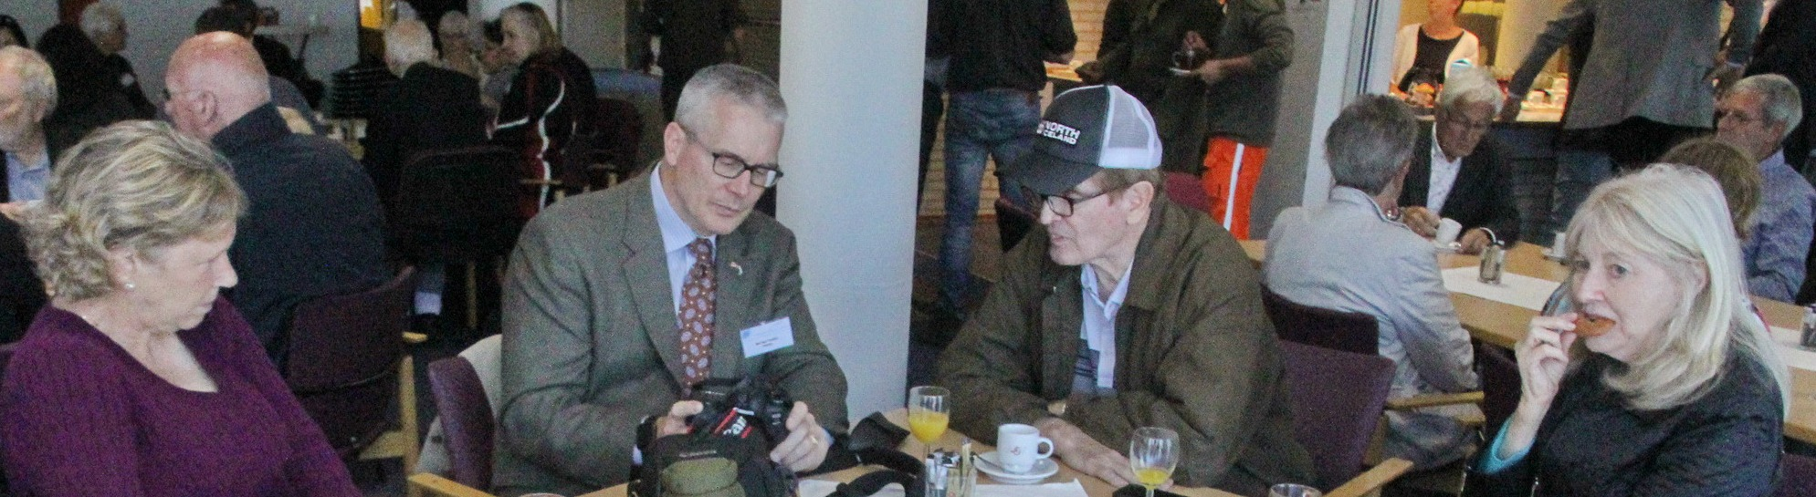

Pat Philbin, Mike Philbin, Brian Philbin and Caroline Scheer

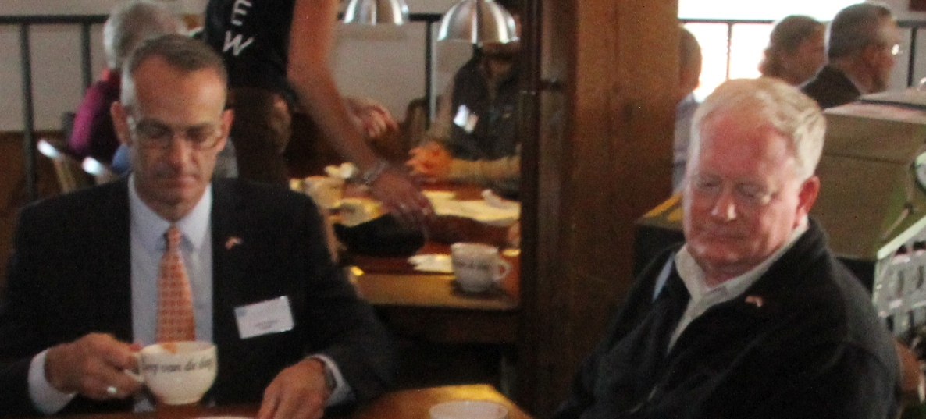

John Hanlon and Douglas Hanlon (photo Mikenzie Hanlon missing)