Dutch Monument Honors Guntersville's Tully and His Crew

* By Anthony Campbell
* Dec 5, 2018
* 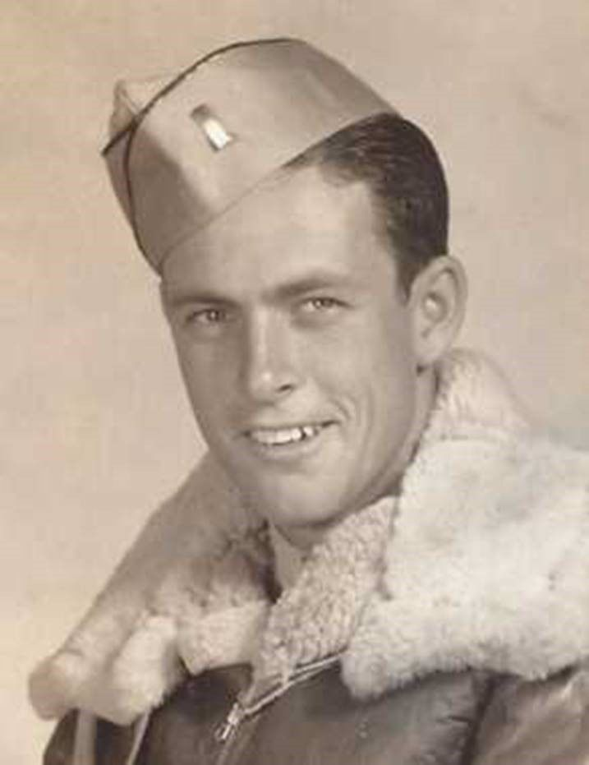

Earlier this fall, members of the Tully family of Guntersville traveled to the Netherlands where a memorial to the crew of the B-17 bomber Mission Belle was unveiled.

The patriarch of the family, O.D. Tully, was one of 10 crewmen in the crippled aircraft when it went down in the Lek River on Dec. 1, 1943, which was exactly 75 years ago last Saturday.

The crew had been in a running gun battle with German fighters across Europe before they finally had to ditch the aircraft. Three members of the crew died in the crash. Tully and the other 6 were taken prisoner and spent nearly 2 years in a prisoner-of-war camp until the end of the war. The late Mr. Tully came home and became the longtime Veterans service officer in Guntersville.

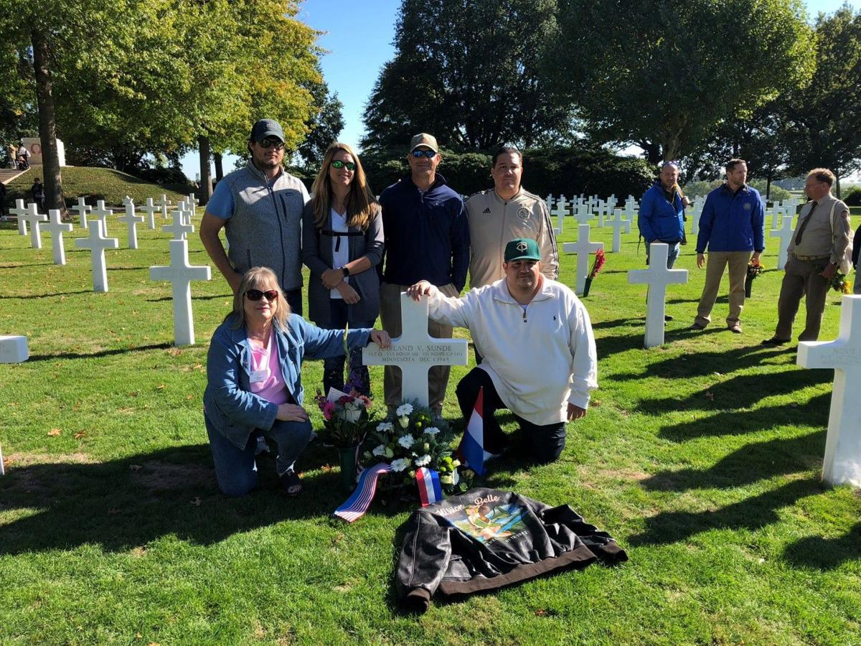

The Tully,Fleming and Aguirre families at the grave of Pilot Harland Sunde. Lt. Tully once said of Sunde, “one of the best mannered and level headed boys I’ve ever met. He drank and cussed very little and his moral code and character couldn’t be surpassed.”

The Tully family home and farm was located near Mitchell Grocery just off of Rose Road in Albertville and today there is a Tully Street in the area. Tully was a graduate of Albertville High School. O.D.'s mother was a part of the Hefner family of Sand Mountain.

After the war, Tully was Bill Yancy’s neighbor and Yancy wrote a book about him entitled “We Knew We Were in For A Long Day.” The book was translated into Dutch and shortly thereafter The Mission Belle Memorial Foundation was started. The Foundation’s mission is to “keep the memory alive of the 10 brave men who flew the Mission Belle.”

The Mission Belle crashed in Nieuw-Lekkerland and that’s where the memorial is located. Members of Tully’s family attending the dedication were Leigh Ann Tully Fleming and Blake Tully. Leigh Ann’s husband Zach was the third member attending. Yancy remembers both Leigh Ann and Blake attended Guntersville High School where Leigh Ann was homecoming queen and Blake a good receiver on the football team.

Yancy provided this write-up from the memorial service by Jennifer Holik, Global Coordinator of the World War II Research and Writing Center.

**The Mission Belle:**

**Freedom Demands Responsibility**

By Jennifer Holik

I attended the day’s events starting in the morning where the Band of Brothers re-enactors, some of whom work at Delware Company who designed the flight suits and some artwork for the event, were in attendance. The usual coffee, tea, and cookies were served as we gathered and waited for the families to arrive. Outside, several WWII trucks and jeeps were waiting which would later transport the family members to the monument.

Just before 11 a.m., the family members arrived. With them arrived the crew and a lot of others from WWII. I stood near the top of the stairs where they entered the room, saying hello and shaking hands, or asking if certain people were ok. While I was there to support my re-enactor friends, honor the crew, and attend the unveiling, it was clear that I was also there to help provide peace, healing and space for everything and everyone. Several people required this and I was happy to provide it.

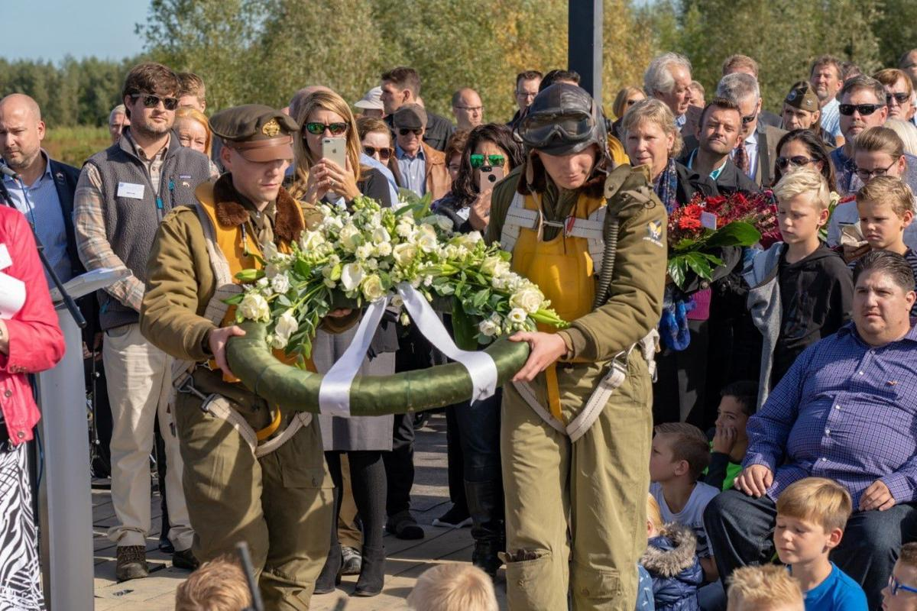

Grandchildren of O.D. Tully, Blake Tully and Leigh Ann Tully Fleming both with shades standing behind one of the Band of Brothers re-enactors laying a wreath at the Mission Belle Memorial

The energy of the entire building shifted as everyone arrived. Many emotions were felt from joy, sadness, relief, disbelief that they were standing in this place, happiness, gratitude, and many other emotions. Several of my friends felt the same when the families arrived. It was clear that a lot of healing would take place for those living and those long gone.

Several speeches were given to the families to describe the history of the Mission Belle, the formation of the foundation, the creation of the monument, and the day’s events. As an American who picks up only a few Dutch words, I was grateful my husband Johan was asked to translate the Dutch stories into English so the American families could understand what was being said.

In the primary speech about the monument and why it is important to have it in the Netherlands, was the idea that freedom is not free, freedom is not a given thing, and freedom demands responsibility in words and deeds. The Netherlands have lived in relative peace for almost 75 years, something unheard of in most countries. The younger generation takes this for granted, as if freedom has always been present. It has not and the Dutch are determined to help keep the memory alive of those who fought and died for their freedom

A couple of eye witnesses spoke, in Dutch, about the crash of the Mission Belle and what happened to the crew. It was very moving. Then several family members spoke and told stories about their family member who was part of the crew. The families thanked the Dutch for creating the monument and remembering. As one man, Paul, stood and told the story about his family member and read a poem written by his granddaughter, I could see the crew standing behind him in a half-circle providing support to this man who shed many tears as he spoke. A lot of healing took place. I was able to speak to Paul afterward and he, like many other family members, was still in a bit of disbelief they were standing there and everything was happening. Little did they know what else was to come. The Dutch definitely know how to stir the emotions and commemorate the past.

We enjoyed a lovely lunch after the speeches and then the flight crew prepared for the briefing conducted by Joe, a retired Army soldier who had been stationed in Germany for many years. He took command of the airmen and did an incredible job re-enacting a mission briefing for the families. One thing we should always remember about military research – no matter what war we are talking about – is there is always something new to learn. It doesn’t matter how many military reports you’ve read or veterans you’ve spoken to, there is always more to learn, seemingly small details that played a big role in a service member’s day, missions, life, and death. I learned quite a lot listening to Joe speak.

Then the families had some time to gather outside and look at the vehicles prior to loading up in the WWII trucks to take them to the monument site just down the road.

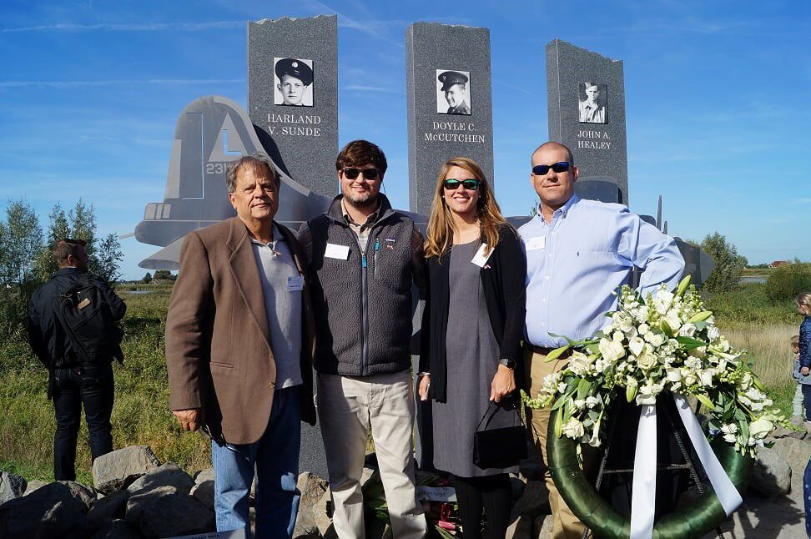

***Bob Christensen, Blake Tully, Leigh Ann Tully Fleming and Leigh Ann’s husband Zach***

***Bob Christensen the son of navigator Roger Christensen. Blake Tully and his sister Leigh Ann Fleming the grand children of bombardier O.D. Tully attended to honor both their grandfather and deceased father Jerry Harland Tully. Roger Christensen the Navigator credits O.D. Tully with saving his life from the sinking plane. One request of Roger before he died of cancer in 1990 was for Megan his wife to call and thank O.D. for saving his life making it possible for them to have a 45 year marriage.***

Johan and I chose to drive ourselves and had to park about a quarter mile away. Walking closer to the monument, we were surprised to see the large crowd gathered. The Dutch tend to come out for commemorations and monument unveilings, but this was the largest crowd I’ve seen at a commemoration here so far. One newspaper article reported over 300 people in attendance. I would agree.

The three that died that day are honored with the tall stones with the seven survivors listed on plaques mounted on stone below

Several speeches were given and of course the children participated by reading poems. Dutch children participate in every commemoration because Freedom isn’t Free or a Given, Dutch children are taught about WWII and the lasting effects in the hope that history will not repeat itself.

After the speeches, wreaths were laid by the Mission Belle Foundation, the Americans, the family members, the city, and other organizations. Then the families came up to lay their flower bouquets around the monument.

Two drummers moved in and then Taps was played. Following Taps, the American and Dutch National Anthems were played as the flags were raised. Apollo from the movie Band of Brothers was played and then two airplanes did a fly over once, turned around and did a missing man formation over us as they flew back to their base. It was a beautiful ending to a moving ceremony.

I was able to speak to one of the sons of an airman, both before we went to the monument and after the unveiling. He was so moved and a bit overwhelmed by the day’s events and emotions, in a good way. He too was surprised at how many people came to the event, that the children participated, and the beautiful words spoken in the speeches. I have the awareness he found a lot of peace and closure – for that I am grateful

The families went to Margraten to visit the graves of two of the crew members. hope they all found some answers and peace they were seeking. I hope we all continue to share the stories of the war and create a peace-filled future.

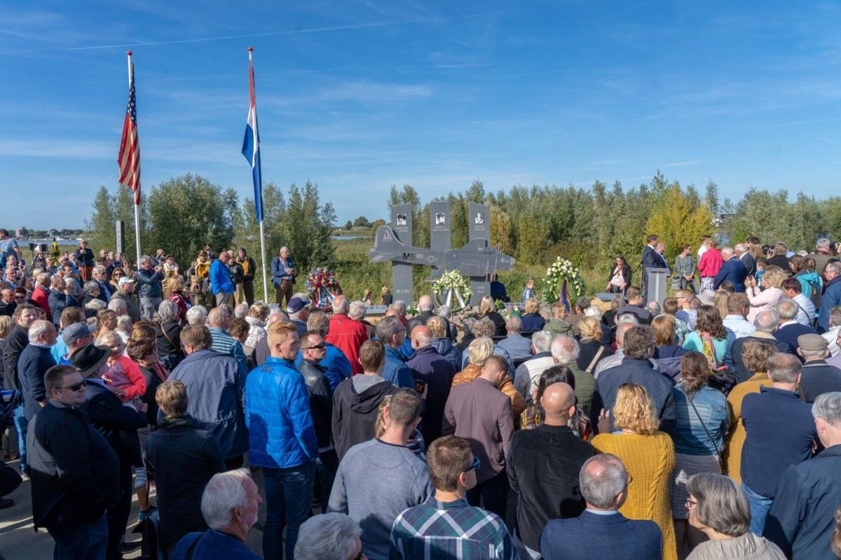

The Foundation newsletter reported 500 people attended the dedication service

**Eyewitnesses Speak**

Two eyewitnesses to the crash landing of the Mission Belle spoke at the ceremony, Yancy said.

Here are their remarks:

**Pleun de Groot**

It was December 1st, 1943. I was 8 years old. We were between 1 and 2 o’clock of the afternoon with three persons in the cow barn. We heard the loud roaring of plane engines. It was a bomber, shot to pieces, coming from the west and flew very low over our farm. A German fighter followed the bomber, shooting it. Several bullet casings fell down on the yard near the farm. The 20 cows didn’t know how to react; they howled terribly. They were very upset. It seemed to be a miracle that the bomber didn’t crash on the farm. I saw it through the windows of the cow barn, dropping very quickly. The plane went down into the Lek River.

The rescue started. At night, the survivors were taken prisoner by the Germans and brought away. Also these people, our friends, who with thousands of others, fought for our freedom against the Germans. That’s why we are here, to remember that with the family and friends from America. I thank you for that.

In 1954, Frank Pot of ‘de Koophandel’ demolition firm wanted to lift up the plane with a hoist and a knot around an engine of the plane. The motor broke off the wing and the plane sank back into the depth of the river. The motor with the propeller was thrown in the reeds. Together with other boys we could spin the propeller around

I have been in military service as well in 1955, and lucky enough I didn’t experience war. So far, that seems to be a miracle from God, as we think about war in the Middle-East and in so many other countries. In Margraten are more than 8.000 American soldiers buried also the two men who drowned near Nieuw-Lekkerland, during the rescue efforts. They died in the struggle for freedom. Their sacrifice was not in vain, because the victory was ours.

Let us close with the Bible, God’s words about Job: ‘The Lord has given, the Lord has taken, the name of the Lord be praised.’

**Anton den Ouden:**

As a nine year old boy, I was fishing on December 1st, 1943, in the Lek River, near the Schoonzicht bar. Suddenly I got startled by very low flying planes, shooting at each other in pursuit. I quickly took cover under some steel masts of ships, which were stored near the river.

I went back to the side of the river, to see where they went. They disappeared out of sight, and I only heard some noise and shooting from the other side of the river. So I picked up my fishing-rod and started fishing again.

But they came back, flying lower and with more noise, so I took cover again under the masts. When the planes passed by, I quickly took a look, until they disappeared when they were near the “Van Duijvendijk” ship yard. I didn’t see the bomber anymore, but the small fighter was still flying around.

I quickly took my fishing-rod and went home with wet (pee) pants on. There came the bad news. My mother didn’t allow me to go fishing in the river again.